SPS Storage

sps-storage-bybgfta9dne2b5bw.qatarcentral-01.azurewebsites.net/login

Login Credentials,

**Admin: adminx@example.com/123**

**Venue Admin 1 (Lusail): va1@example.com/va1_12345**

**Operator (Lusail): operator1@example.com/Opera123!**

Admin View:

Venue-Admin View:

Operator View:

Operator Mobile View

(When scanning the blue QR Code for a **Mobile Camera**, remember you have to login once as an operator)

Spectators:

sps-storage-bybgfta9dne2b5bw.qatarcentral-01.azurewebsites.net/index? e=8&v=8&l=12&s=16

e is Event, v is Venue, l is Location, s is Storage Type

Event: FIFA ARAB CUP QATAR 2025™

Venue: LUS - Lusail Stadium

Location: Window 1

Storage Type: Restricted Items Storage

The QR Code below is

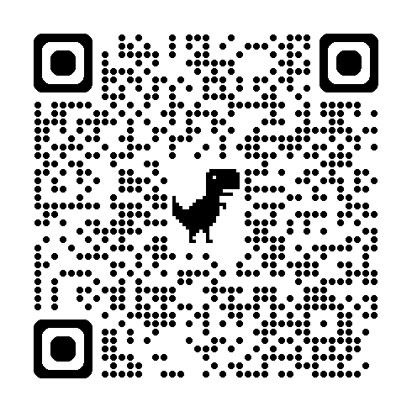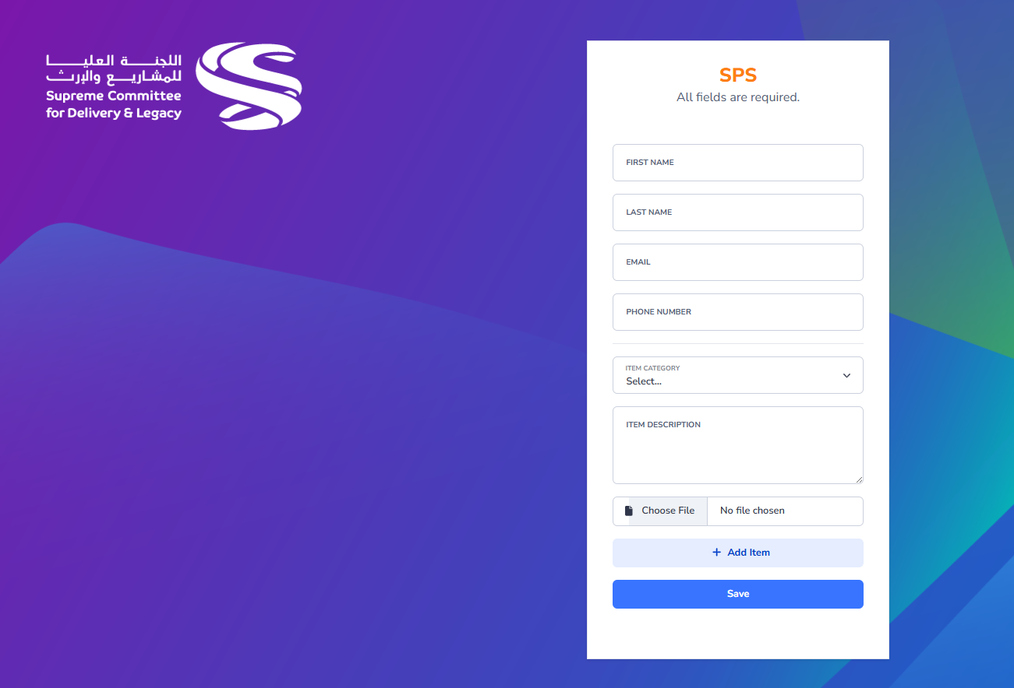

When filled and email will be delivered with 2 QR code confirmation.

Black and blue. The blue is for mobile scanning.

